Pedigree REGISTer manual | Alpaca Breeder Step by step guide for navigating the Alpaca Association of Ireland’s Pedigree Registry  Helen Eivers  Author

Contents
Getting Started 2
Logging In 2
Menu Layout 2
My Data 3
Persons 4
Animals 5
Simple animal search 5
Pedigree 8
Viewing animal ancestry 8
Viewing animal progeny 8
Printing animal certificates 8
Viewing animal photo 8
Animal Breeding statistics 8
Birth Notifications 9
Registering the Birth of a Cria 9
Step 1 Birth Notification 9
Step 2 Add Additional Information 18
Viewing cria ancestry 20
Viewing cria progeny 20
Printing cria certificates 20
Viewing cria photo 20
Advanced Searching 21
Power Search 21
Searching for animals by Breeder 23
Searching for animal by Farm 3 letter prefix 24
Output retrieved data to Excel/PDF 24
Power search for animal pedigree and certs 25
Searching for persons 26
Emailing from the database 27

Getting Started

Logging In

Go to the Internet Site :
https://aai.chromosoft.eu/login
Login with the Username and Password provided to you by either the Membership Secretary or the Registry Officer.
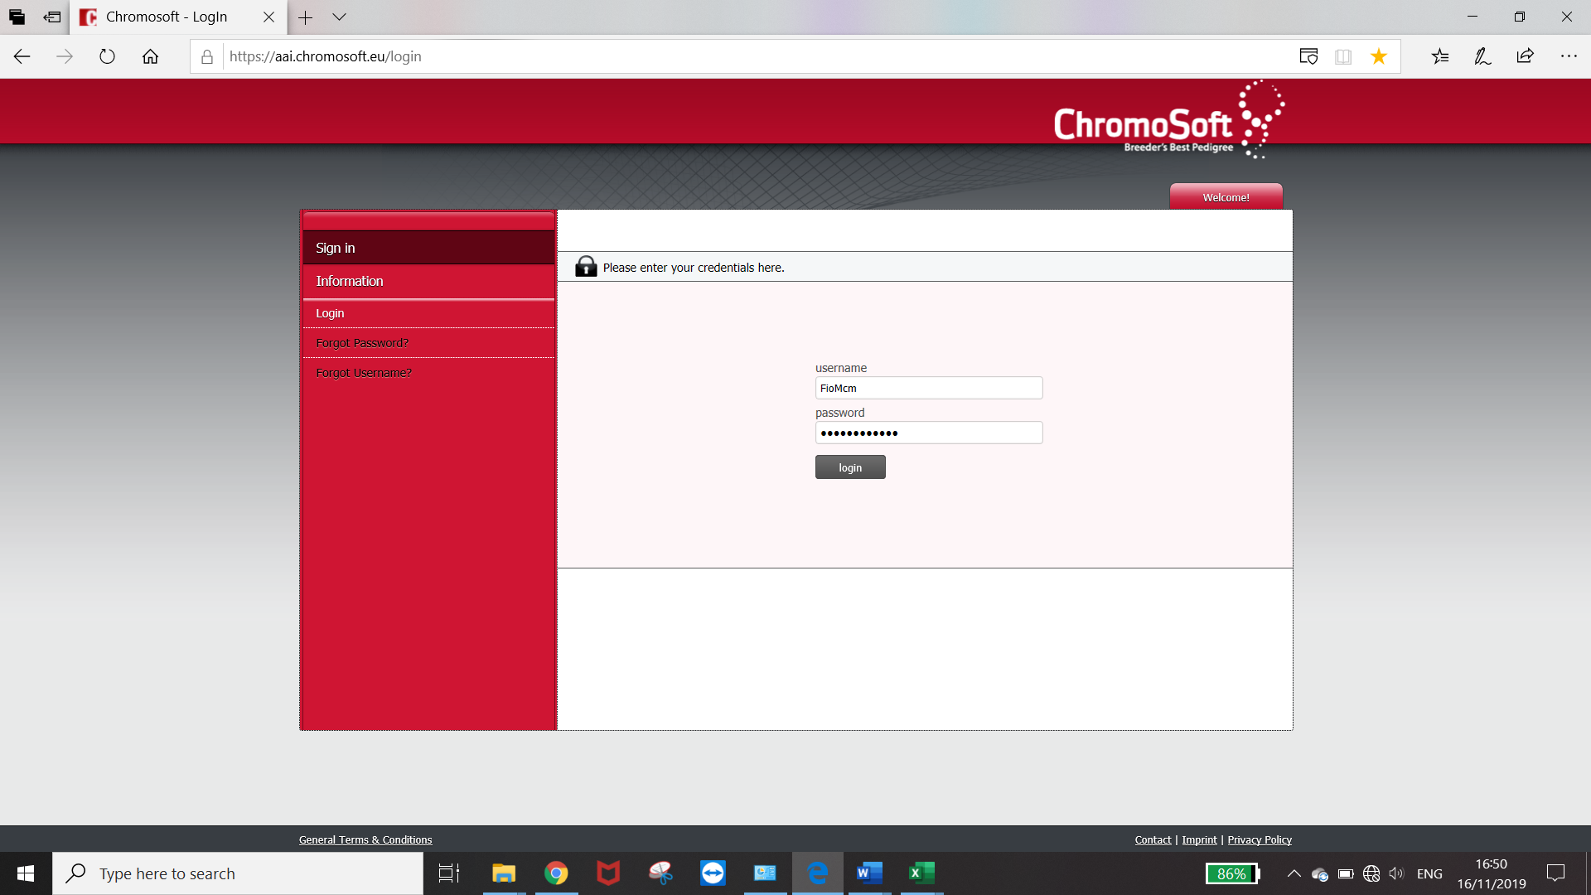

Menu Layout

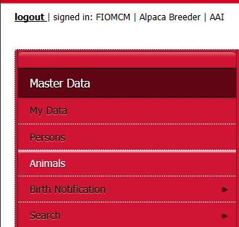
The Top Row contains the Logout option and gives you basic information on who and where you have logged in
Signed in : This is the User Name of the current login
In the next field the type of User that is signed in, in this example the user is an Alpaca Breeder and therefore has access to the animal register and can notify the register of new births.
The next field displays to who’s register the user has logged in. This will always read AAI for our register.

The Panel in red displays all the menu’s listed under the header Master Data that this type of user, “Alpaca Breeder” has access to.
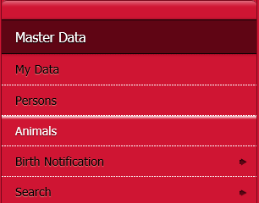

Menu 1 – My Data
Menu 2 – Persons
Menu 3 – Animals
Menu 4 – Birth notifications
Menu 5 – Search

My Data

My data holds basic information about the User that is logged in. Information on address and other contact details. A photo or logo of the farm under the picture tab and if a breeder the animals registered to this user.
The individual user can decide not to enter some or all of their contact details which will mean that this will also not be available to other members.
Note: Street name is being used by the AAI for Farm Name so please always have this populated

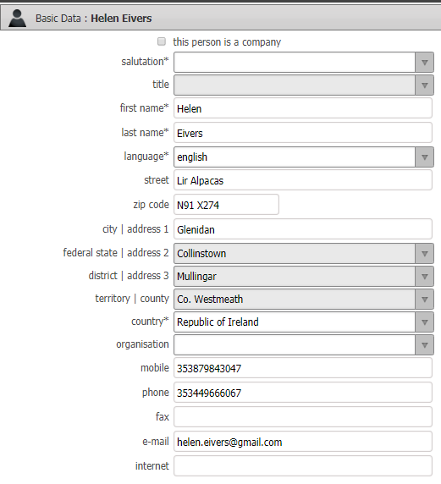

Persons
Persons is a register of all the persons associated with the animal register and includes current members, past members, owners including ancestory owners etc.
If a person has chosen to supress their contact information details in “My Data” such as therir address information it will then not be available here.
At a minimum name and status within the association will be displayed.
For GDPR reasons historical information on past members etc, is not kept by the AAI without explicit permission.
To Search the persons Register enter criteria in the search panel and hit the magnifyin glass

Additional criteria is enabled by 1st choosing the options button which will display additional dropdown search criteria
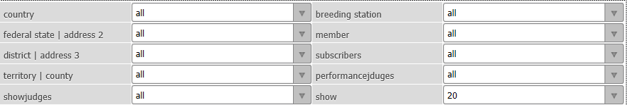

Animals
Animals is the register of all the animals on the register including ancestors. Basic information can be added/edited here by all users however it is not possible to add a new animal as ancestory can only be added via birth notifications for non adminstrators
For more details on how to add/edit details Go to: Step 2 Add additional information for instructions
Track and trace is available to the adminstrator of the register so changes to historical records will be observed and will need to be explained.

Simple animal search
To view a specific animal on the register go to the animal menu in the red panel and a listing of the animals on the register will display on the right.
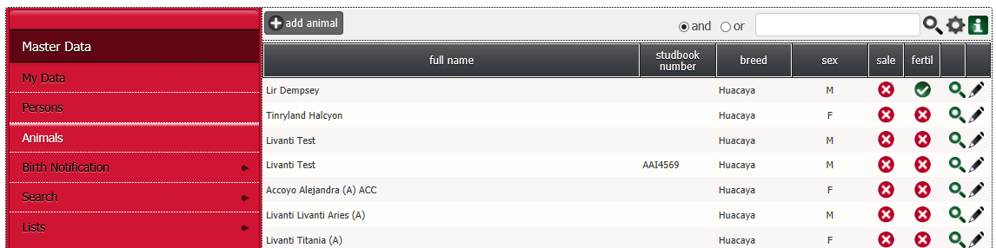
Select from the list by scrolling through the pages at the bottom until you find the record you are looking or by searching for applicable word (s) in the search panel.

The search panel can be used to search by animal name, partial name, breeder surname, breeder 3 digit prefix, Ear tag no. etc.
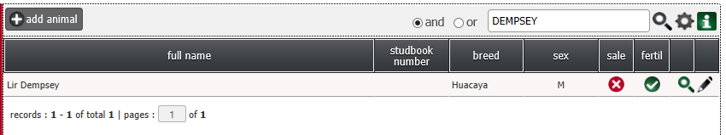
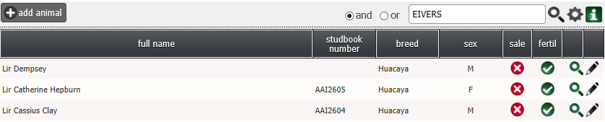

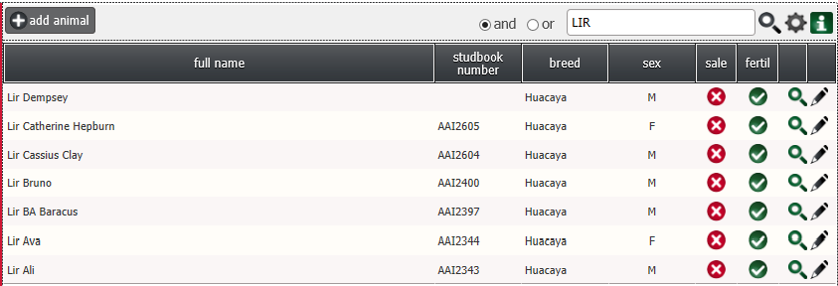
Word of caution: do not assume that if you enter the breeder 3 letter prefix in the search panel that only that breeders animals will be returned, any records that also include those 3 letters will also be returned. To make specific searches go to the Search menu on the red panel.

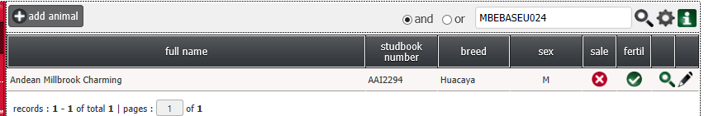
Or even a partial of the Ear Tag “024”
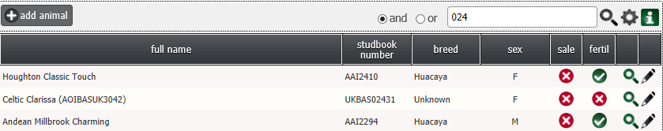

Once you have found the animal record you wish to view select the Magnifying glass on the right of the screen . A page will display with a number of symbols on the left.
Below is a listing of the symbols and their meaning.
Information about the animal itself – Mother, Father, etc.
Information of the original breeder of the animal
Information on the current owner of the animal
A photo of the animal if it has been uploaded
Additional information about the animal if loaded

Example of output
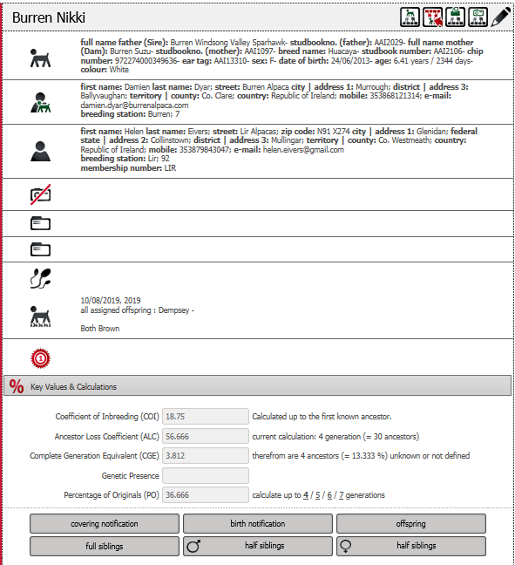
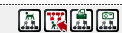
Also available in this screen are all the details on pedigree

Pedigree
At the top of the screen you can extract certain information about the animal using the below symbols

Hover over each symbol to determine what each one does. These symbols are also available in a number of different menus and will produce the same information. Remember for a Cria there will be no progeny available

Viewing animal ancestry
Pedigree – Gives the Ancestors of animal

Viewing animal progeny
Reverse Pedigree – gives the progeny of the animal which will be blank with a cria

Printing animal certificates

Pedigree Certificate template – enables a template to be printed to provide with the animal in the event of a sale. The cert requires the breeders signature and the acquiring owner to be a valid certificate.

Viewing animal photo

Pedigree Photo – Only available if uploaded during Step 2 when adding additional detail to the animal record.

Animal Breeding statistics
Additional information about the breeding statistics of the animal are displayed here and can be used to eliminate the potential of any In-Breeding. The AAI will provide more details on how best to use this information in future publications.
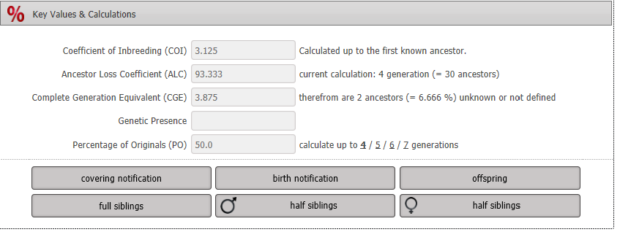

Birth Notifications
Birth notifications are where a Breeder can record the birth of a new Alpaca and effectively add it to the Pedigree Register. Both the Sire and the Dam need to exist on the register for a birth notification to be possible.

Registering the Birth of a Cria
There are 2 steps to add a Cria to the register:
Step 1 is the Birth Notification which requires only minimal information. The Sire, the Dam, the Breeder (known as Breeding Station in this software), the Gender and the Name.
Step 2 Is adding additional information such as colour, Ear Tag etc. Step 2 is not necessary immediately.
The Association will invoice for all Step 1 Birth Notifications immediately, will charge an additional charge if Step 2 is not completed within 3 Months of Notification and will delete the record if not completed within 6 months of Birth Notification

Step 1 Birth Notification
To notify the Register of a Birth Select Birth Notifications from the Menu on the left
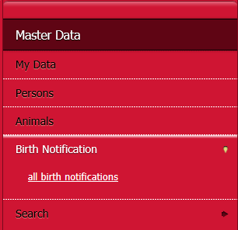
Now you will see an expanded Birth notification menu on the left and a list of all the recent birth Notifications in Date of Birth Order
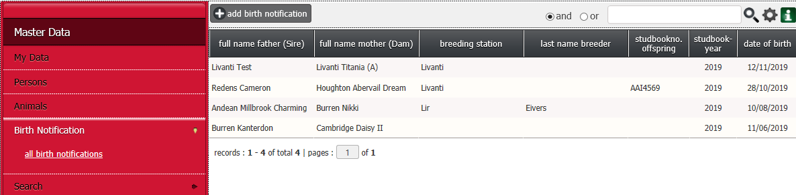

To add a Birth Notification Select from the top of the screen + Add Birth Notification
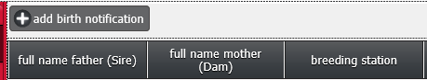

The below information will be requested.
Note you can only add a Cria yourself if the Sire and Dam Exist on the AAI Registry. If one or both do not exist on the Register then please contact the Registry Officer who’s details can be found on our website http://alpaca.ie/alpaca-association/committee/
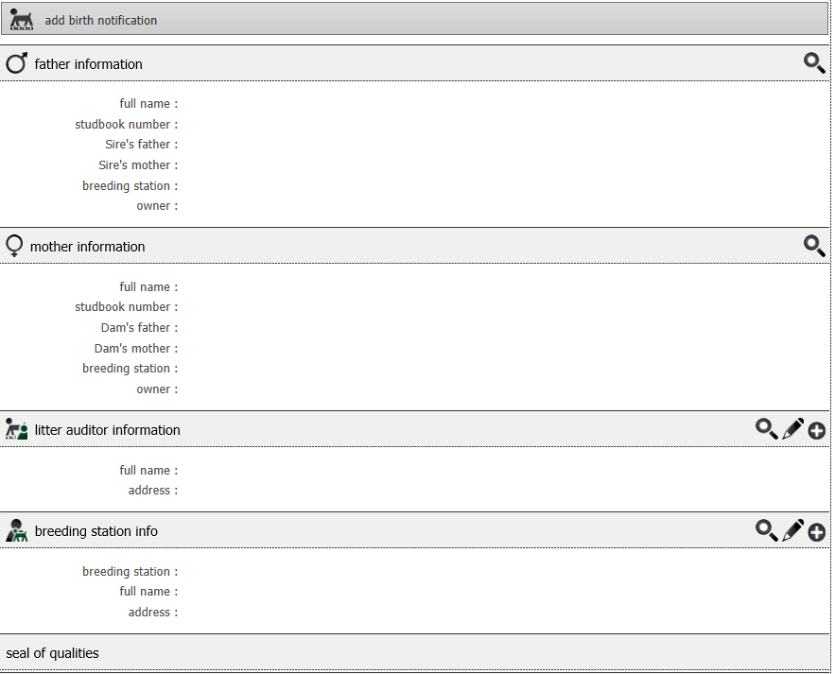
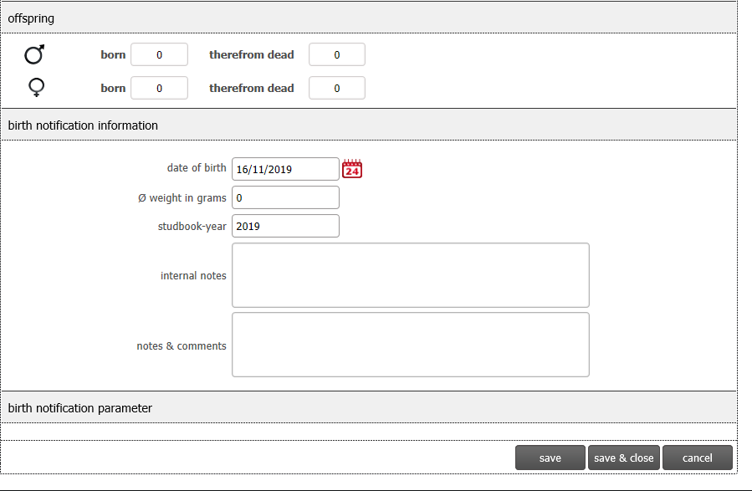
Begin by searching for the Sire by using the magnifying glass

A List of available Sires on the Register will appear.
Find the Sire you are looking for by Searching for applicable word (s) in the search panel or by scrolling through the pages at the bottom
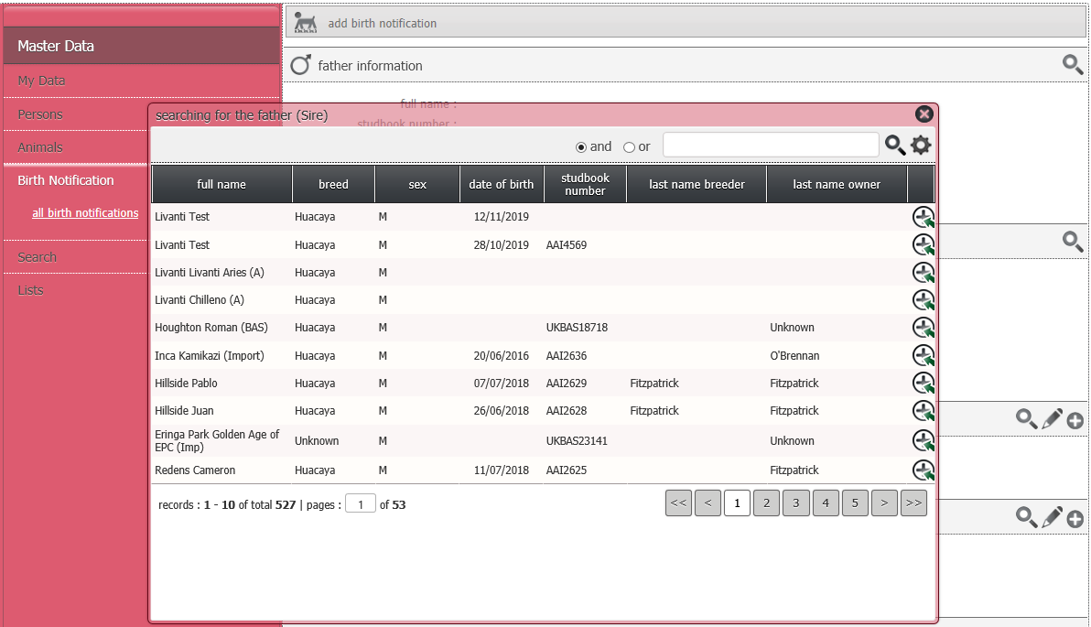

In my example I have entered Ali in the search panel and 3 options are returned. One because the animals name is Ali the other 2 because Ali is within the spelling of their names Galileo, Excalibur
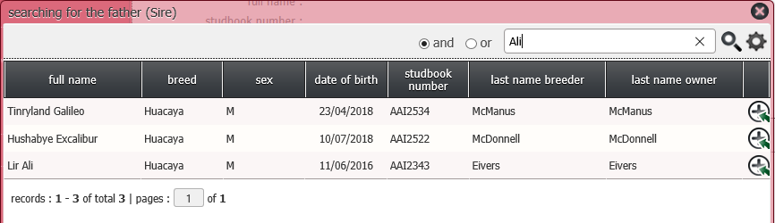

Another Search possibility could have been “eivers” and all the males owned by this person will appear as available
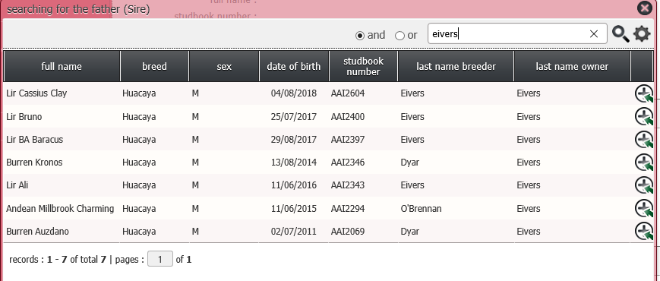
Another Search possibility could have been “lir” (farm prefix) and all the males bred by this breeder will appear as available
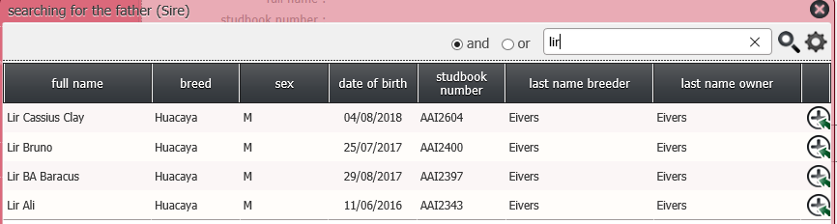
Another Search possibility could have been “MBEBASEU024” the Ear Tag of the Sire
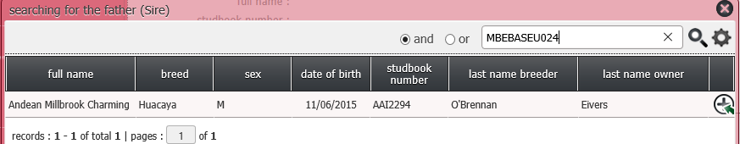
Or even a partial of the Ear Tag “024”
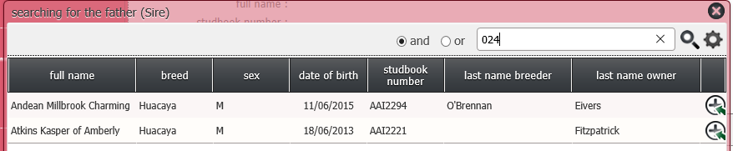

Choose the Sire by selecting the Symbol on the far right of the animals name
The chosen Sire’s details will appear in the 1st panel of the birth notification
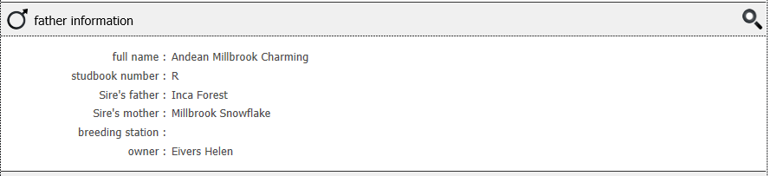

If you have made a mistake simply reselect the Magnifying Glass

Next follow the same process to add the Dam
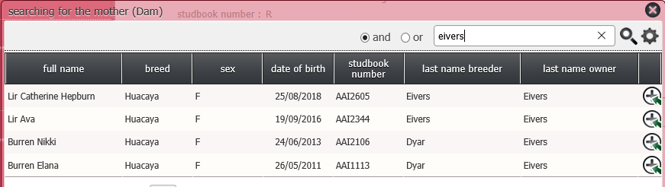

Choose the Dam by selecting the Symbol on the far right of the animals name
The chosen Dam’s details will appear in the 2nd panel of the birth notification
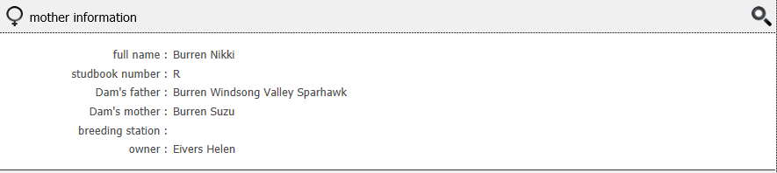

If you have made a mistake simply reselect the Magnifying Glass

The next section can be ignored as it is intended for Societies who require independent physical verification of the birth.

The Next section is the Breeding Station or as we know it the Breeder.

Again select the magnifying glass NOT the pencil or the + symbol
If you choose the by mistake the program will take you out of the birth notification and you will have to start again.

It is VERY important that you choose the correct breeder. as the Breeder’s 3 digit identifier will become the prefix of the Cria’s registered name e.g. in this example “Lir”.
The AAI will invoice the breeder for the birth notification as this is the registered owner at birth.

Again, there are multiple ways of searching for the correct Breeder using the search panel. Remember in most cases you will be searching for yourself as the breeder
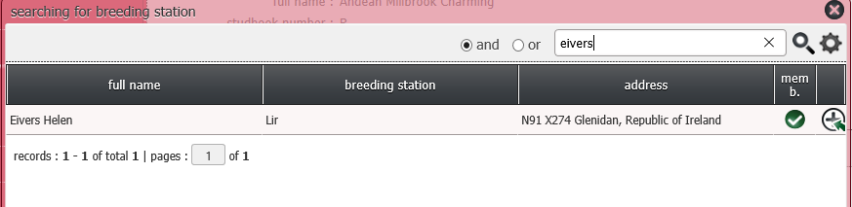
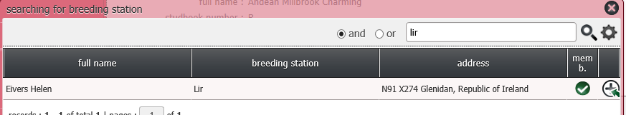

Choose the Breeder by selecting the Symbol on the far right of the animals name
The chosen Breeder’s details will appear in the 4th panel of the birth notification

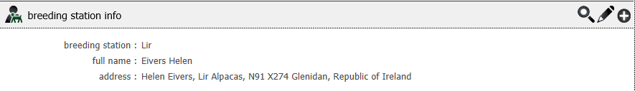

The Next section is where you record the Gender of the Cria

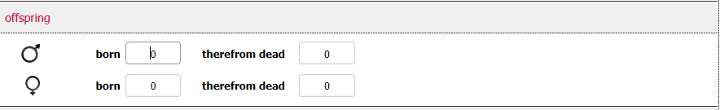

If a male cria then enter a 1 in the box beside the correct symbol
Male

Female

No need to enter anything in the 2nd box as this intended for Litters and this field is to record any losses in the litter

Once you enter a 1 in the male or female row click into another field/area and additional boxes appear for completion. The cria’s given name and the studbook number.

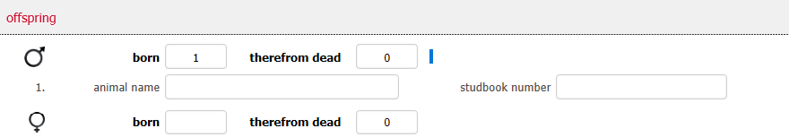

For the animal name enter the “given name” for example “Ali” remembering that the final registered animal name will be a combination of the Breeder prefix and the given name “Lir Ali”
For the Studbook number – Leave this blank. This will be assigned at the time of Invoicing or in time may be automatically populated.

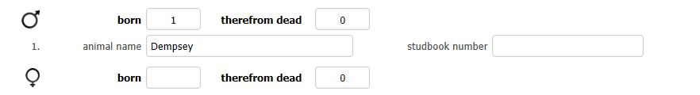

The chosen cria gender and name are now populated in the 5th panel of the birth notification

Next is to record the actual date of birth of the cria and any additional information you might like to record like weight or birthing details. Only the D.O.B. is mandatory.
The default date will be todays date. To choose a different date select the calendar symbol beside the D.O.B. field

Note Weight is measured in grams so 10000 = 10 Kg
The studbook year will default to the calendar year which is correct
Record any notes that you would like to record about the birth itself

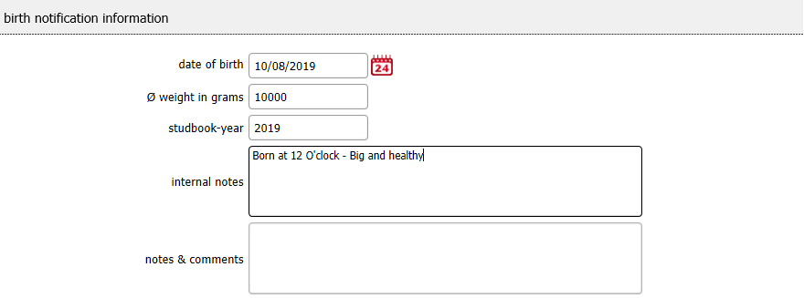

Next record the eye colour of the cria by selecting from the drop down menu
The association may in the future require additional information to be recorded in this section of the birth notification and should something new appear refer back to the on-line manual on our website which will be updated if there are changes to this section.
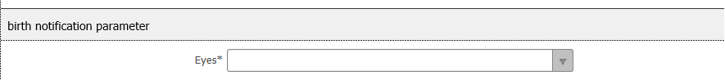

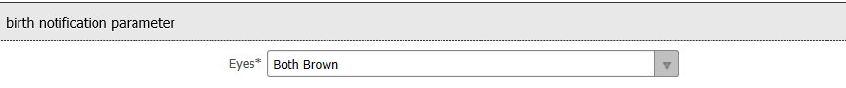

This is the final step before saving
Choose Save, Save & Close or cancel
Choosing Save creates the Birth Notification for which you will be charged
If after saving you notice an error edit the field appropriately and re save

When you are happy that the details are correct select “Save & Close” and you will be exited from the birth notification and returned to the birth notification menu where you will notice your new notification listed in order of D.O.B.
If after this point you notice an error it can be amended during Step 2 (see below)
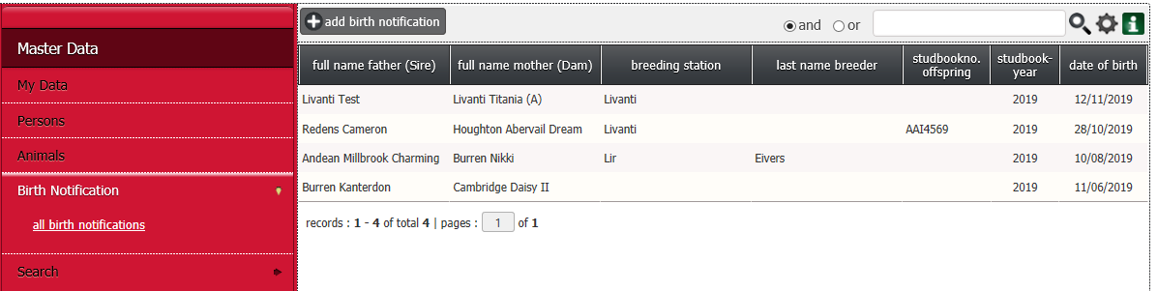

If you have more notifications to make restart the process by selecting + add birth notification

Step 2 Add Additional Information

By creating the birth notification you have also created a skeleton record on the animal register.
To add additional detail select the Animal Menu from the left hand side of the screen in the red panel

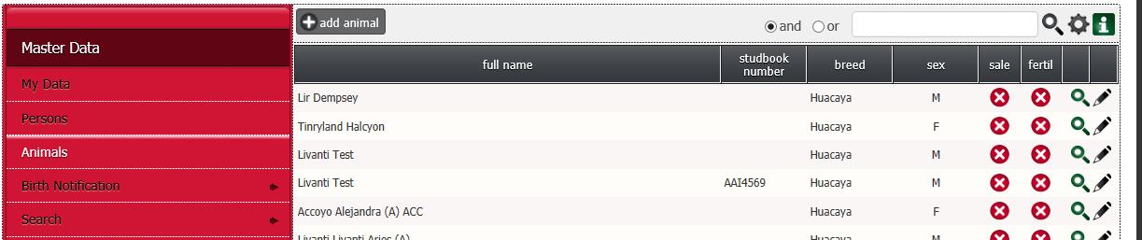

The live animal register will appear on the right hand side of the screen and your birth notification should be listed near the top and if not use the search panel to search by the cria’s name.

Select the pencil on the far right of the record to add the additional detail
The following screen will appear, where you can add the additional detail relevant for the future identification of the cria.

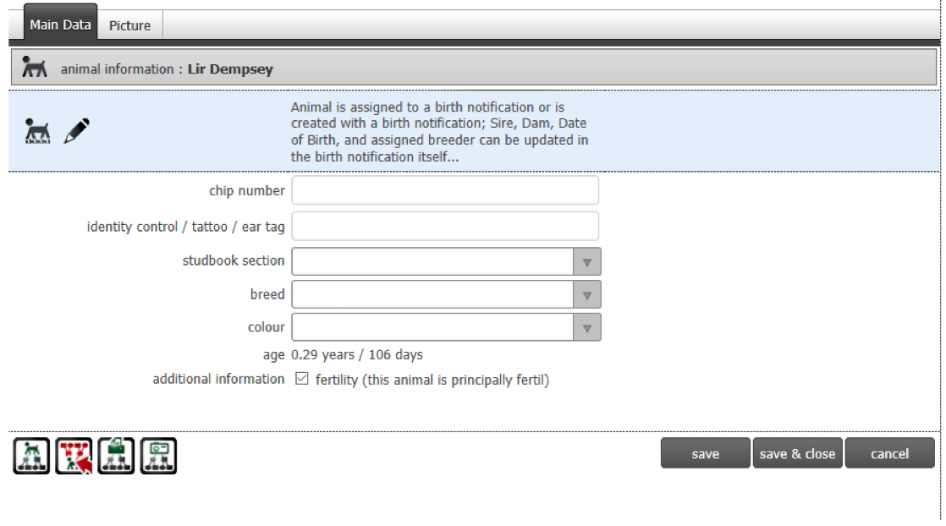

As mentioned earlier this data can be added up to 3 months after the notification free of charge. Between 3 and 6 months there will be an additional charge, please refer to the registration rules for the up to date matrix of charges after 6 months of non-completion the birth notification record will be deleted.
In the blue panel the birth notification record can be re-accessed and edited if an error is discovered at this point – Choose the pencil to re-open the birth notification.

Proceed to complete the additional fields using the below table to guide you

Field | Data to be entered
Chip number | Electronic chip number inserted under skin
Eartag | The unique Breeder herd number
Studbook Section | Graded Partial Pedigree Female  Non Breeding Pet Alpaca  Notified Male  Pedigree Alpaca
Breed | Choose from Huacaya/Suri/Unknown
Colour | Choose from drop down list

Finally, tick the box if the animal is considered to be principally fertile.
This can be amended at a future date should that statement need to be changed.
When Complete choose Save, Save & Close or cancel
Below example of record complete excluding Chip number (to be added later)
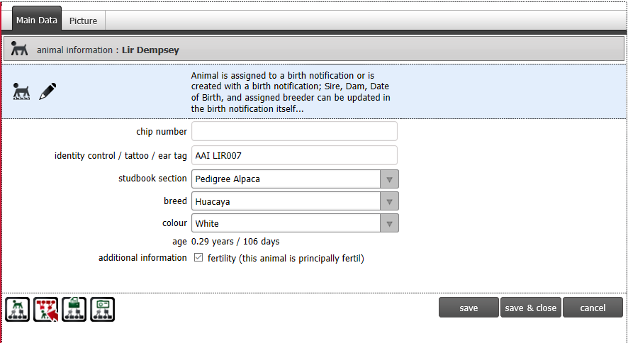
Once Complete Save or Save and close
If you wish to add a photo of the Animal select the 2nd TAB at the top of the screen

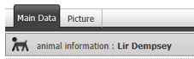

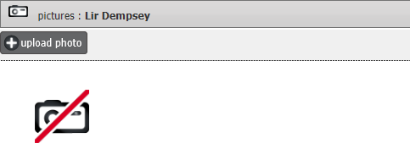

Choose +Upload Photo and select photo pre-loaded in your computer

Once Complete Save or Save and close

At the bottom of the screen are the following four boxes which enables you to see lineage information on the cria, print a certificate and view the loaded photo (if any)

Viewing cria ancestry
Pedigree – Gives the Ancestors of animal

Viewing cria progeny
Reverse Pedigree – gives the progeny of the animal which will be blank with a cria

Printing cria certificates
Pedigree Certificate template – enables a template to be printed to provide with the animal in the event of a sale. The cert requires the breeders signature and the acquiring owner to be a valid certificate.

Viewing cria photo
Pedigree Photo – Only available if uploaded during Step 2 when adding additional detail to the animal record.

Advanced Searching

Power Search
Power search enables search’s of the person and animal register using one or more criteria.
Output of the data selected is possible to multiple media excel or PDF and can then be saved locally
To search the register using multiple parameters go to the Search menu in the red panel and select power search
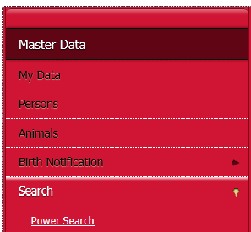

Multiple fields become available and can be searched using one criteria or multiple criteria.
Once the criteria have been completed either the Animal or Members Register can be searched
Remember to select which register you want to search after you have entered your criteria in any of the fields by ticking persons or animals before clicking on the magnifying glass
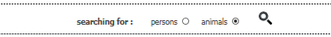

There are two tabs in which criteria can be entered – Animal’s Data or Person
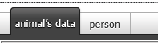

On the Animal’s Data Tab you can search by Given name, Breeding station (Breeder farm name), chip number, Ear tag, Studbook Number etc. | On the Person Tab you can search by Last name, Breeding station (Breeding Farm Name) etc.
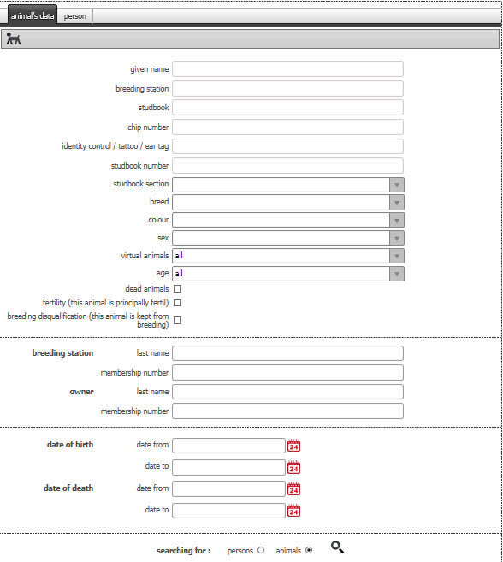
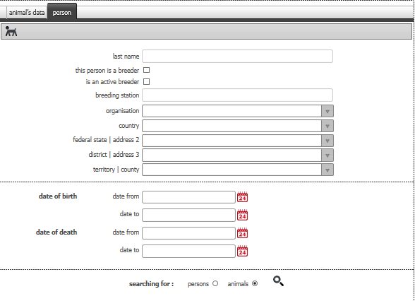

Remember to select which register you want to search after you have entered your criteria in any of the fields – Person or animals
Then run your request by choosing the Magnifying glass

Searching for animals by Breeder
In this example I have entered LIR in breeding station in the animals tab and the output has returned all the animals bred by this Breeder
Entered Criteria | Output

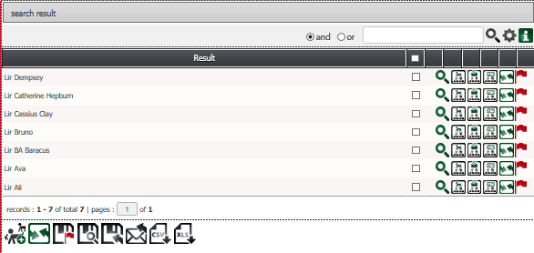
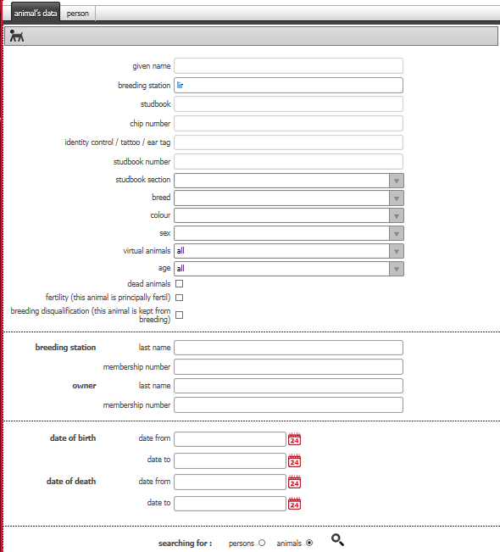

If I want all the animals owned by this breeder then I would enter the breeding station (3 letter farm prefix) on the persons tab or the last name,this would return all the animals owned by this breeder

Entered Criteria | Output
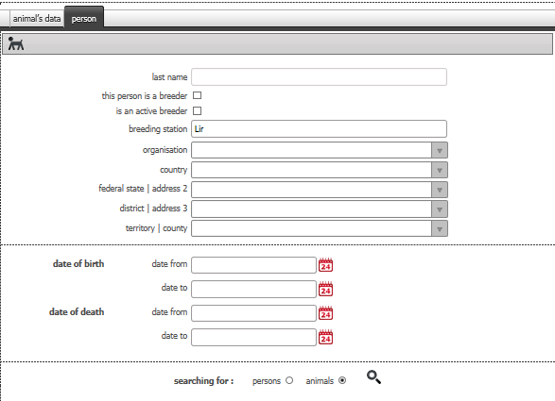
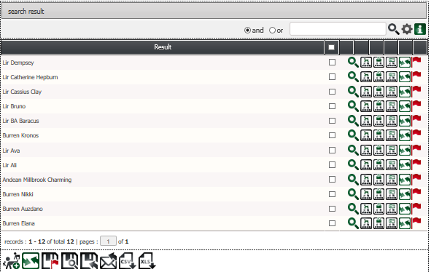

Searching for animal by Farm 3 letter prefix

If you know the farm 3 letter prefix you can use this to search by using the 2nd panel on the animal tab

Enter for example TIN in Membership number under breeding station if you want animals bred by Tinryland or enter TIN in Membership number of owner if you want animals owned by Tinryland

Output retrieved data to Excel/PDF
When the search result displays on screen you have the option of outputting to excel or PDF one or more of the lines in the result.
Do this by ticking the box at the top for all items
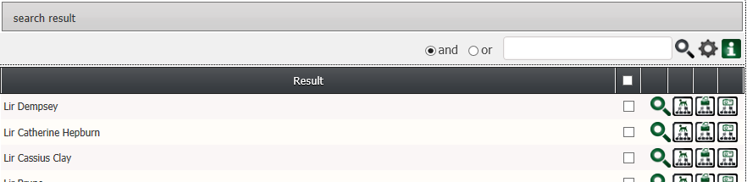

Or select one by one if you only want to output some of the data

Once you have your selection ticked navigate to the bottom of the screen to select type of output
Click on choice e.g. XLS for excel
A message will flash up to say export has been successful and an option to open or save will be presented in a few seconds depending on size of file.
Note: ensure Chromosoft is listed as an approved site in your Internet cookies settings (this is a one off setup)
Select open if you wish to see the results before saving

The following information will be listed.
File/Save as if you wish to keep a local copy or close if you do not

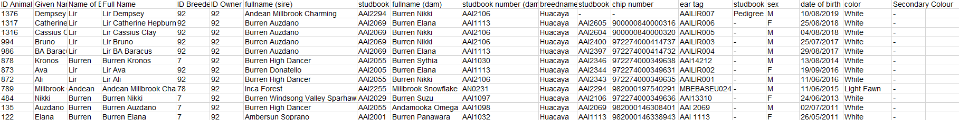

Power search for animal pedigree and certs

From this search screen it is also possible to
view the animal on screen by taking you the animal record itself.
See the animal pedigree
Print the Pedigree Certificate
Print the pedigree photo if uploaded
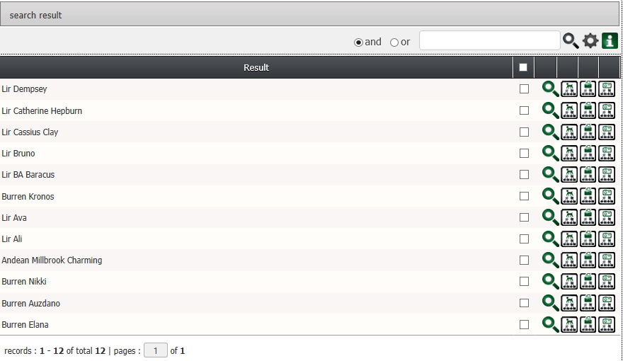

Searching for persons

Search by persons enables individual name searches or leave blank to bring back all
Entered Criteria | Leave all fields blank

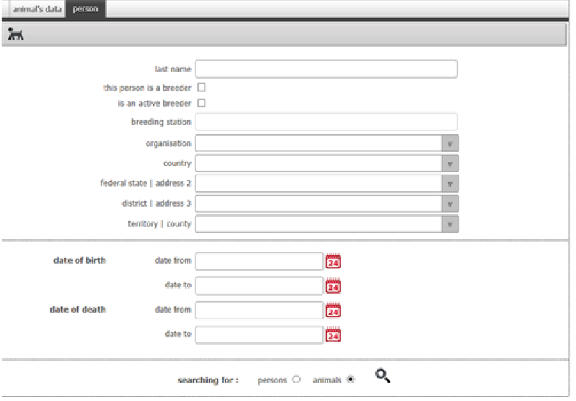
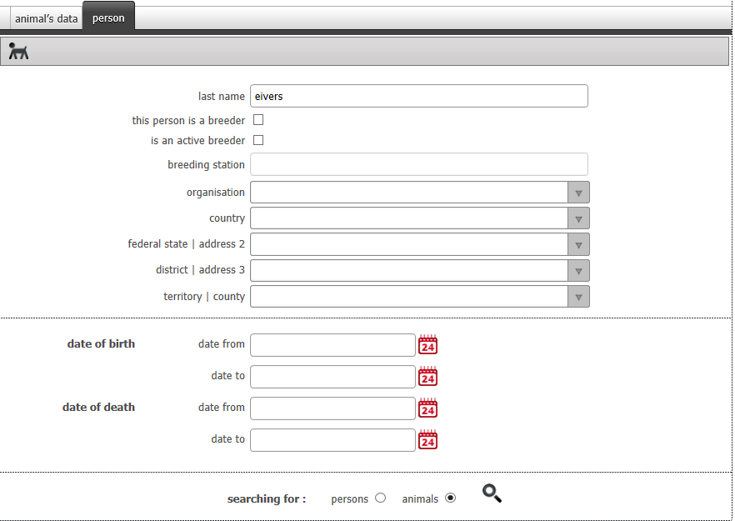
One result as requested | Multiple results
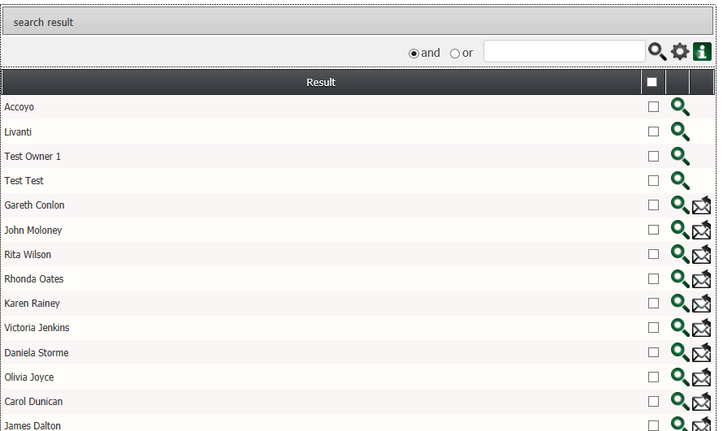
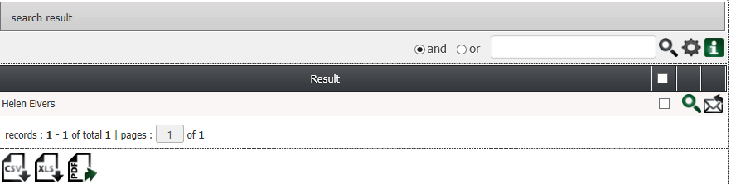

Tick the box at the top of the list if you want to select all or tick individual boxes if you only want to select some from the list. Use the search panel to further search the list.
Then navigate to the bottom of the screen and select to what you would like to extract.
Click on choice e.g. XLS for excel
A message will flash up to say export has been successful and an option to open or save will be presented in a few seconds depending on size of file.
Note: ensure Chromosoft is listed as an approved site in your Internet cookies settings (this is a one off setup)
Select open if you wish to see the results before saving
The following information will be listed in excel

You cannot go to the persons details using the magnifying glass like you can in the animal listing as this area is restricted.

Emailing from the database
Assuming the person you wish to email has listed their email address as being available to other members you can also sent a short message from the database.
Listed beside each name that has their email registered is an envelope

If you would like to send a quick email click on the envelope and a message box appears
Type your message and send
