STEP 1
Go to Alpaca Association Website
https://www.alpaca.ie/
(please don’t worry if you get a message that the site is not secure, IT IS, the provider is working on resolving the message)

To set up an account
Choose “sign in” and at the bottom of screen you will be offered the option to create an account.
(this is a one-time exercise)

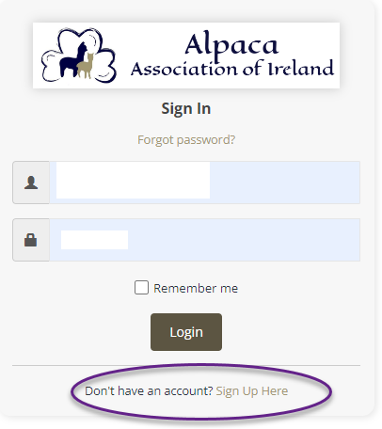

- You will be asked to enter an email address.
- Provide a password.
- Confirm password by entering again.
- Sign up.

A record of your Account Activity will be presented to you.

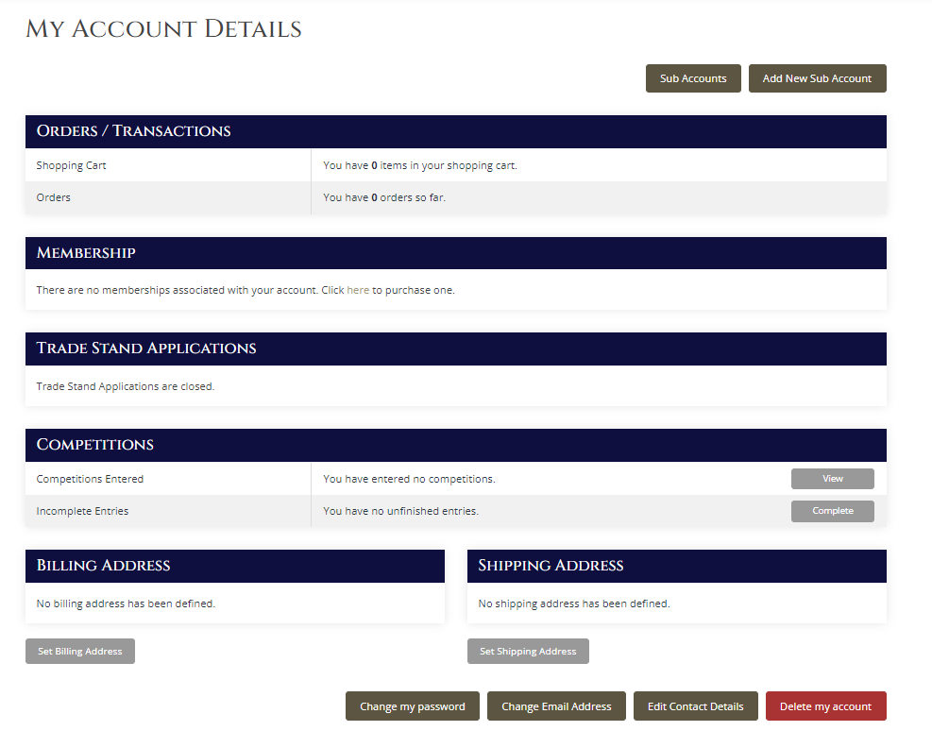

Here you can

- Make purchases from our Shop (more about this in the coming months)
- Pay for your Membership.
- Apply for a trade Stand at Shows (not yet enabled)
- Enter Association Competitions (only National Show enabled for now)

You can also
- set your billing address.
- Set your shipping address.
- Change your password.
- Change your email address.
- Edit your contact details.

That’s it you now have an Official Account with the Alpaca Association of Ireland

