How to enter the National Alpaca Show

STEP 1
Go to Alpaca Association Website
https://www.alpaca.ie/
(please don’t worry if you get a message that the site is not secure, IT IS, the provider is working on resolving the message)

Step 2
If you have an account
Login – Top right of website.

If you don’t have an account
Choose “sign in” and at the bottom of screen you will be offered the option to create an account.
(this is a one-time exercise)
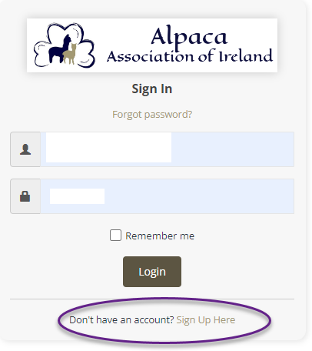

- You will be asked to enter an email address.
- Provide a password.
- Confirm password by entering again.
- Sign up.

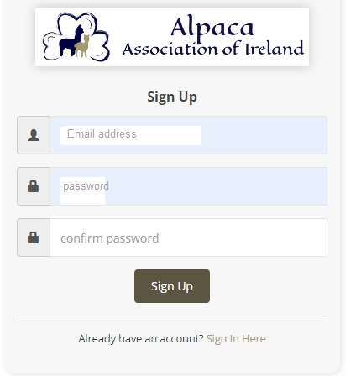
That’s it you now have an Official Account with the Alpaca Association of Ireland

STEP 3
A record of your Account Activity will be presented to you.
Here you can

- Make purchases from our Shop (more about this in the coming months)
- Pay for your Membership.
- Apply for a trade Stand at Shows (not yet enabled)
- Enter Association Competitions (only National Show enabled for now)
You can also
- set your billing address.
- Set your shipping address.
- Change your password.
- Change your email address.
- Edit your contact details.

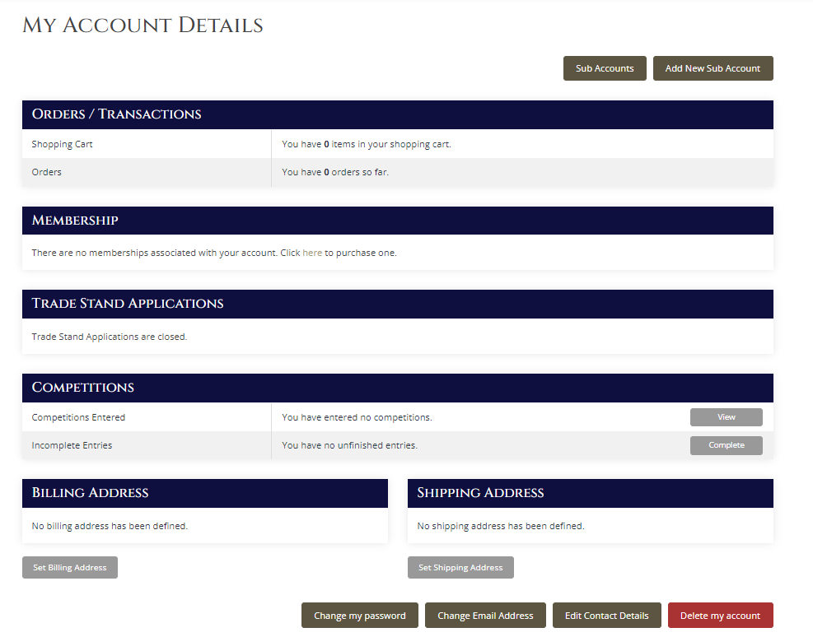

Please Ensure your membership is up to date to be eligible to enter a show.
STEP 4

You Enter competitions by either:
Selecting view from your account as shown below
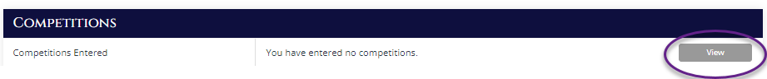
Or by Choosing “Competitions” from the top Ribbon of the website
STEP 5
Select View and Enter competitions and the below screen will appear.

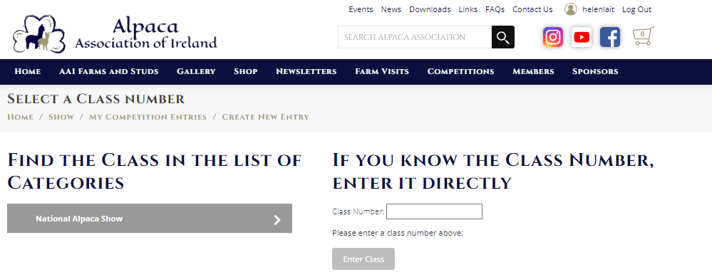
STEP 6
If you know the Class, you are entering then enter the Class Number in the box on the right-hand side of the screen and press enter or choose enter class. See below for a full list of classes which can be entered.
Championship Classes are not listed below as they cannot be directly entered, i.e. can only be entered by winning colour classes etc.
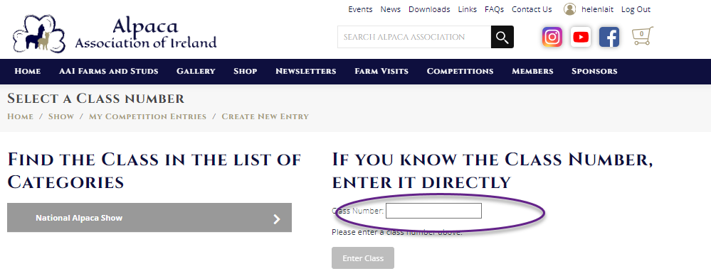
Huacaya Female |  |  | Suri Female
HF100 | Huacaya Female Black Junior |  | SF100 | Suri Female Black Junior
HF101 | Huacaya Female Black Intermediate |  | SF101 | Suri Female Black Intermediate
HF102 | Huacaya Female Black Adult |  | SF102 | Suri Female Black Adult
HF103 | Huacaya Female Black Senior |  | SF103 | Suri Female Black Senior
HF110 | Huacaya Junior Female Brown |  | SF110 | Suri Female Brown Junior
HF111 | Huacaya Intermediate Female Brown |  | SF111 | Suri Female Brown Intermediate
HF112 | Huacaya Adult Female Brown |  | SF112 | Suri Female Brown Adult
HF113 | Huacaya Senior Female Brown |  | SF113 | Suri Female Brown Senior
HF120 | Huacaya Junior Female Fawn |  | SF120 | Suri Female Fawn Junior
HF121 | Huacaya Intermediate Female Fawn |  | SF121 | Suri Female Fawn Intermediate
HF122 | Huacaya Adult Female Fawn |  | SF122 | Suri Female Fawn Adult
HF123 | Huacaya Senior Female Fawn |  | SF123 | Suri Female Fawn Senior
HF130 | Huacaya Junior Female Light |  | SF130 | Suri Female Light Junior
HF131 | Huacaya Intermediate Female Light |  | SF131 | Suri Female Light Intermediate
HF132 | Huacaya Adult Female Light |  | SF132 | Suri Female Light Adult
HF133 | Huacaya Senior Female Light |  | SF133 | Suri Female Light Senior
HF140 | Huacaya Junior Female White |  | SF140 | Suri Female White Junior
HF141 | Huacaya Intermediate Female White |  | SF141 | Suri Female White Senior
HF142 | Huacaya Adult Female White |  | SF142 | Suri Female White Intermediate
HF143 | Huacaya Senior Female White |  | SF143 | Suri Female White Adult
HF150 | Huacaya Junior Female Grey |  | SF150 | Suri Female Grey Junior
HF151 | Huacaya Intermediate Female Grey |  | SF151 | Suri Female Grey Intermediate
HF152 | Huacaya Adult Female Grey |  | SF152 | Suri Female Grey Adult
HF153 | Huacaya Senior Female Grey |  | SF153 | Suri Female Grey Senior
HF160 | Huacaya Junior Female Multi |  | SF160 | Suri Female Multi Junior
HF161 | Huacaya Intermediate Female Multi |  | SF161 | Suri Female Multi Intermediate
HF162 | Huacaya Adult Female Multi |  | SF162 | Suri Female Multi Adult
HF163 | Huacaya Senior Female Multi |  | SF163 | Suri Female Multi Senior

Huacaya Male |  |  | Suri Male
HM200 | Huacaya Junior Male Black |  | SM200 | Suri Male Black Junior
HM201 | Huacaya Intermediate Male Black |  | SM201 | Suri Male Black Intermediate
HM202 | Huacaya Adult Male Black |  | SM202 | Suri Male Black Adult
HM203 | Huacaya Senior Male Black |  | SM203 | Suri Male Black Senior
HM210 | Huacaya Junior Male Brown |  | SM210 | Suri Male Brown Junior
HM211 | Huacaya Intermediate Male Brown |  | SM211 | Suri Male Brown Intermediate
HM212 | Huacaya Adult Male Brown |  | SM212 | Suri Male Brown Adult
HM213 | Huacaya Senior Male Brown |  | SM213 | Suri Male Brown Senior
HM220 | Huacaya Junior Male Fawn |  | SM220 | Suri Male Fawn Junior
HM221 | Huacaya Intermediate Male Fawn |  | SM221 | Suri Male Fawn Intermediate
HM222 | Huacaya Adult Male Fawn |  | SM222 | Suri Male Fawn Adult
HM223 | Huacaya Senior Male Fawn |  | SM223 | Suri Male Fawn Senior
HM230 | Huacaya Junior Male Light |  | SM230 | Suri Male Light Junior
HM231 | Huacaya Intermediate Male Light |  | SM231 | Suri Male Light Intermediate
HM232 | Huacaya Adult Male Light |  | SM232 | Suri Male Light Adult
HM233 | Huacaya Senior Male Light |  | SM233 | Suri Male Light Senior
HM240 | Huacaya Junior Male White |  | SM240 | Suri Male White Junior
HM241 | Huacaya Intermediate Male White |  | SM241 | Suri Male White Intermediate
HM242 | Huacaya Adult Male White |  | SM242 | Suri Male White Adult
HM243 | Huacaya Senior Male White |  | SM243 | Suri Male White Senior
HM250 | Huacaya Junior Male Grey |  | SM250 | Suri Male Grey Junior
HM251 | Huacaya Intermediate Male Grey |  | SM251 | Suri Male Grey Intermediate
HM252 | Huacaya Adult Male Grey |  | SM252 | Suri Male Grey Adult
HM253 | Huacaya Senior Male Grey |  | SM253 | Suri Male Grey Senior
HM260 | Huacaya Junior Male Multi |  | SM260 | Suri Male Multi Junior
HM261 | Huacaya Intermediate Male Multi |  | SM261 | Suri Male Multi Intermediate
HM262 | Huacaya Adult Male Multi |  | SM262 | Suri Male Multi Adult
HM263 | Huacaya Senior Male Multi |  | SM263 | Suri Male Multi Senior

Class Reminders
 | Age as at Show Date
Junior 6-12 months | DOB: Between 9th Mar 2023 and 8th Sept 2023
Intermediate 12-24 Months | DOB: Between 9th Mar 2022 and 8th March 2023
Adult 24-48 Months | DOB: Between 9th Mar 2020 and 8th March 2022
Senior 48 months + | DOB: 8th Mar 2020 or earlier

If you don’t know the Class, you are entering then follow the arrows until you get to the class you are wishing to enter as shown below for Huacaya/Female/Black/Junior. Note: you will need to ignore the championship classes until you get to the class which displays as shown below with a tick box

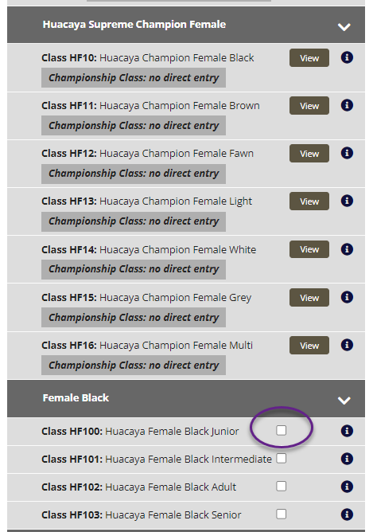

Step 7
Select , the entry fee will be displayed Choose

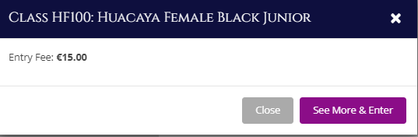

You will be taken to a form where all the information required to enter a competition will be requested.

If you have not completed your contact details etc. when setting up your account, you will be asked to do so before being able to proceed.

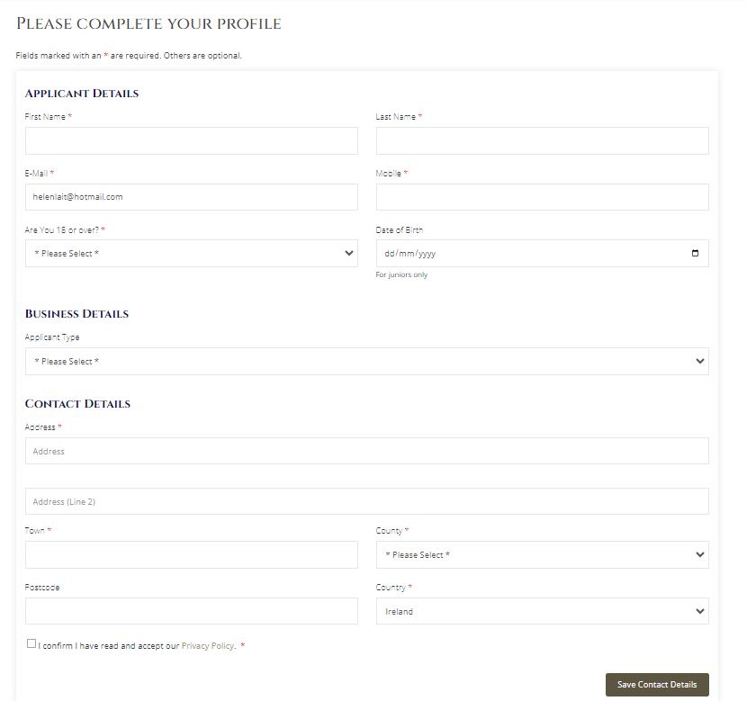

STEP 8
Complete the form.
Double check you have selected the correct class before continuing.
90% of the information you need to complete this form can be found on your animal pedigree certificate. Contact Adrian Murphy on alpacaregistry@gmail.com if you do not know how to find this.

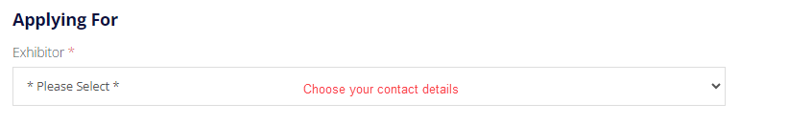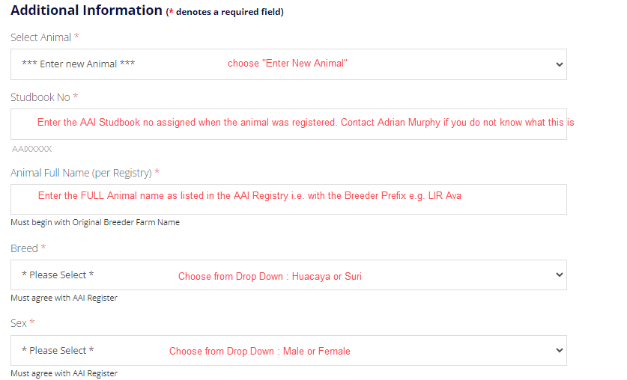

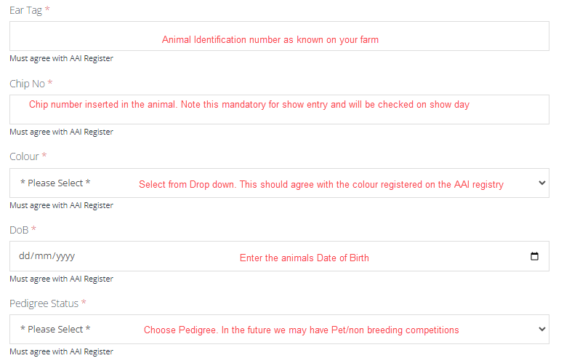

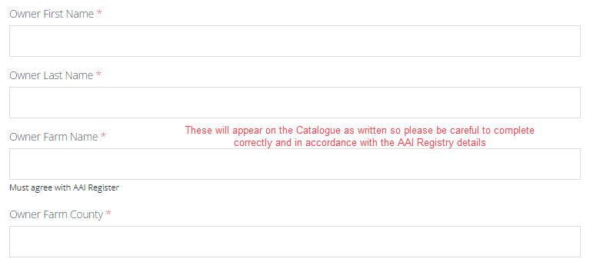

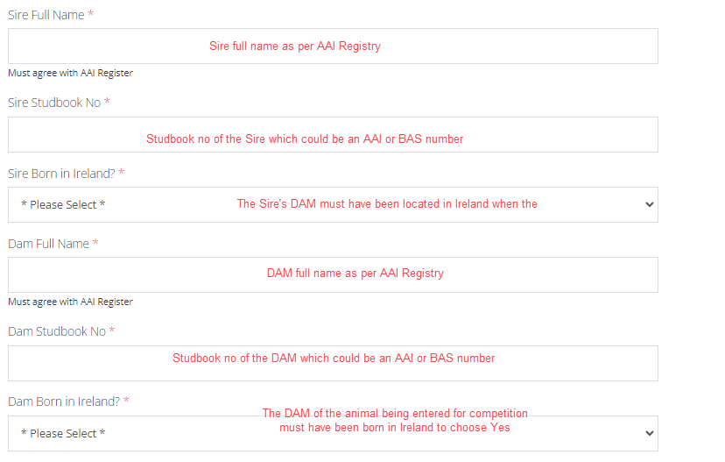
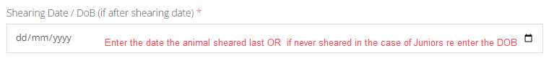
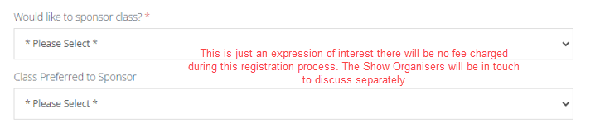

Once you have completed all the Mandatory fields marked with a red symbol * choose “Next”

Step 9: You will be asked to review and confirm your entry.
If you spot a mistake, don’t worry you can edit your entry by selecting Edit Entry
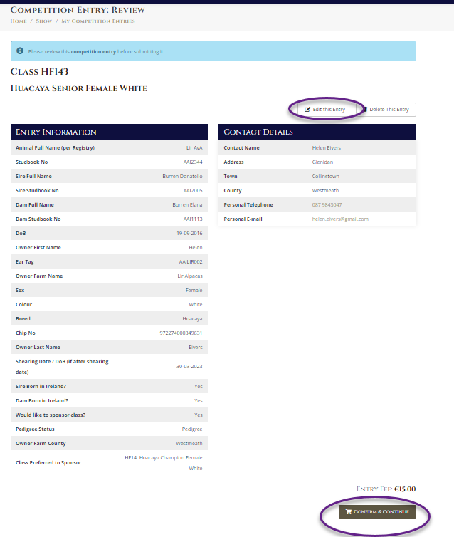
Step 10: If you are happy with all your entry details choose “Confirm and Continue”.

Step 11: If you have more animals to enter, choose “Add New Entry” and repeat the process.

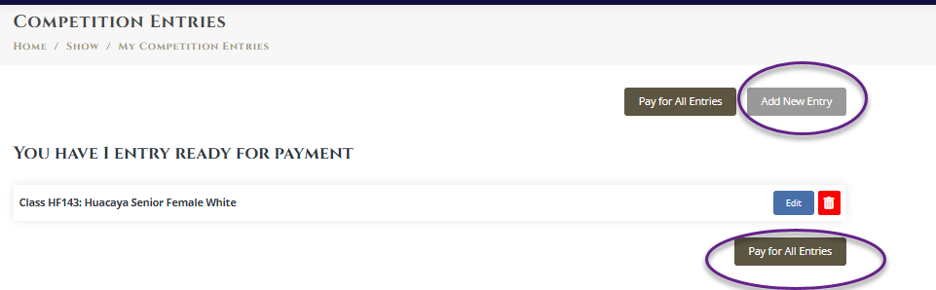

Step 12: If you have finished making your entries choose “Pay for all Entries. And a list of all your purchases will be shown. Choose “Pay with Card” to proceed.

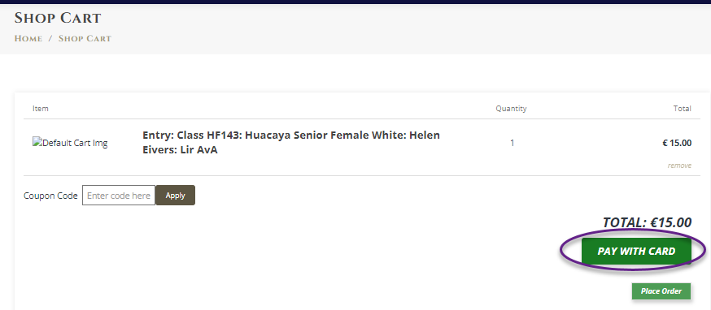

Step 13: You will be given the opportunity to edit your Billing Information.
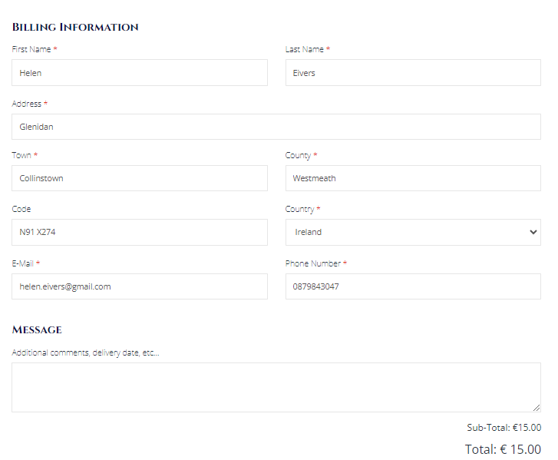

Step 14: Finally enter your card details and PAY.

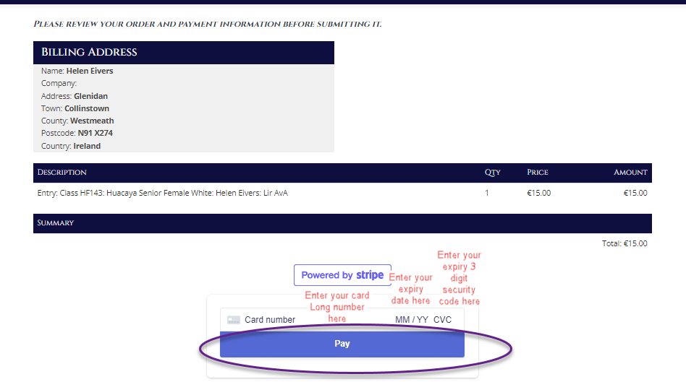

Once payment is successful you will be issued with an order reference

All activity under your account is retrievable at any time by selecting your name from the top right of the Association website – as shown below.
Highlighted below Membership is paid up until 31/12/2024 and one competition entry has been made.
