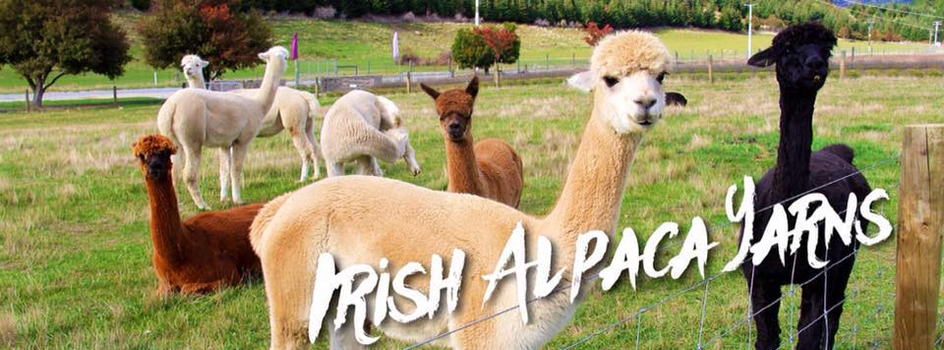
Irish Appointed Agent. Patricia Kerr
Lecklin Lodge
LeckLintown
K32 CX86 Co Dublin.

Alpaca Association of Ireland Craft Show Results
I would like to express a very big thank you to Tim Hay for his judging of the competition. Tim has a great to appreciation of the time, detail and efforts that go into all the entries.
Also thank you to everyone who entered this annual competition and who crafts with Alpaca Fleece as they help to grow appreciation and love of Alpacas and the Alpaca Fibre Industry in Ireland.

Supreme Champion Crafter and Champion Knitter - Anne Mathers’ entry no 52 Ladies hand knit cable Jacket.
Champion Hand Spun Crafter and Champion Crochet and recipient of the superfine fleece sponsored by Amberly Alpacas - Aisling Kerr’s entry no 22 Grey Rose crochet Wedding Shawl.
Champion Weaver - Maire Ni Neachtain’s entry no 63 hand spun and hand woven Scarf
Champion Felt Crafter - Claire Graham’s entry no 17 Wild Atlantic Way Table Lamp which lit up the whole area with striking colours.

Knitting
Large Garments
1st Anne Matthers - Cable Jacket
2nd Janet White Spunner - Childs Jackets
3rd Anne Mathers - Cardigan
4th Velma Merser

Small Projects / Accessories
1st Rita Willson Baby Set –booties and bonnet
2nd Veronique Canning - Fingerless mitts
3rd Rita Wilson – Purse
4th Janet White Spunner baby Blanket
5th Janet Whit Spunner - Scarf
6th Rita Wilson Cowel

Crochet
Large Garments
1st Aisling Kerr - Grey Rose Wedding Shawl
2nd Aisling Kerr - Irish Lace Crochet Jacket
3rd Aisling Kerr - Red Roses Shawl
4th Mary Cooper – Jumper with Mohair
5th Marina Vetner - Jumper

Small Projects
1st Adele Johnston - Hand spun Baby Blanket and Bonnet
2nd Laura Milanese - Crochet Neck Warmer Jewellery
3rd Olga Slipcheke - crochet Bonnet
4th Gemma Hughes – Beanie
5th Meherin McLoughlin – Crochet Doilie
6th Laura Milanese - crochet scarf

Weaving
1st Maire Ni Neachtain - Hand spun and woven Scarf
2nd Sandra King Hand Spun and Woven Cape
3rd Janet Whit Spunner - Hand spun and woven Scarf
4th Janet Whit Spunner - Hand spun and woven Scarf

Felting
1st Claire Graham - Wild Atlantic Table Lamp
2nd Claire Graham - Felted Scarf with silk
3rd Helene Dooley - Light Lamp Shade
4th Helene Dooley - Plant Holder
5th Helene Dooley - Volcano Erruption.

Novelties
1st Rita Wilson - Little Girl
2nd Janet White Spunner - Rocking Mice.

